Self-Centering Camera

Camera that changes angle. Uses object detection. Servo motors on both the x & y axis to go in all directions. The motors take signals from camera or microchip.

* Problem: Can’t have both servos going through camera, causes jams. Put y-servo on the camera and mount on a plate that’s spun by the x-servo

The code will be using math to calculate the center of the screen with the detection box. The box will have a width and a thickness, so just need the screen width and do math.

* 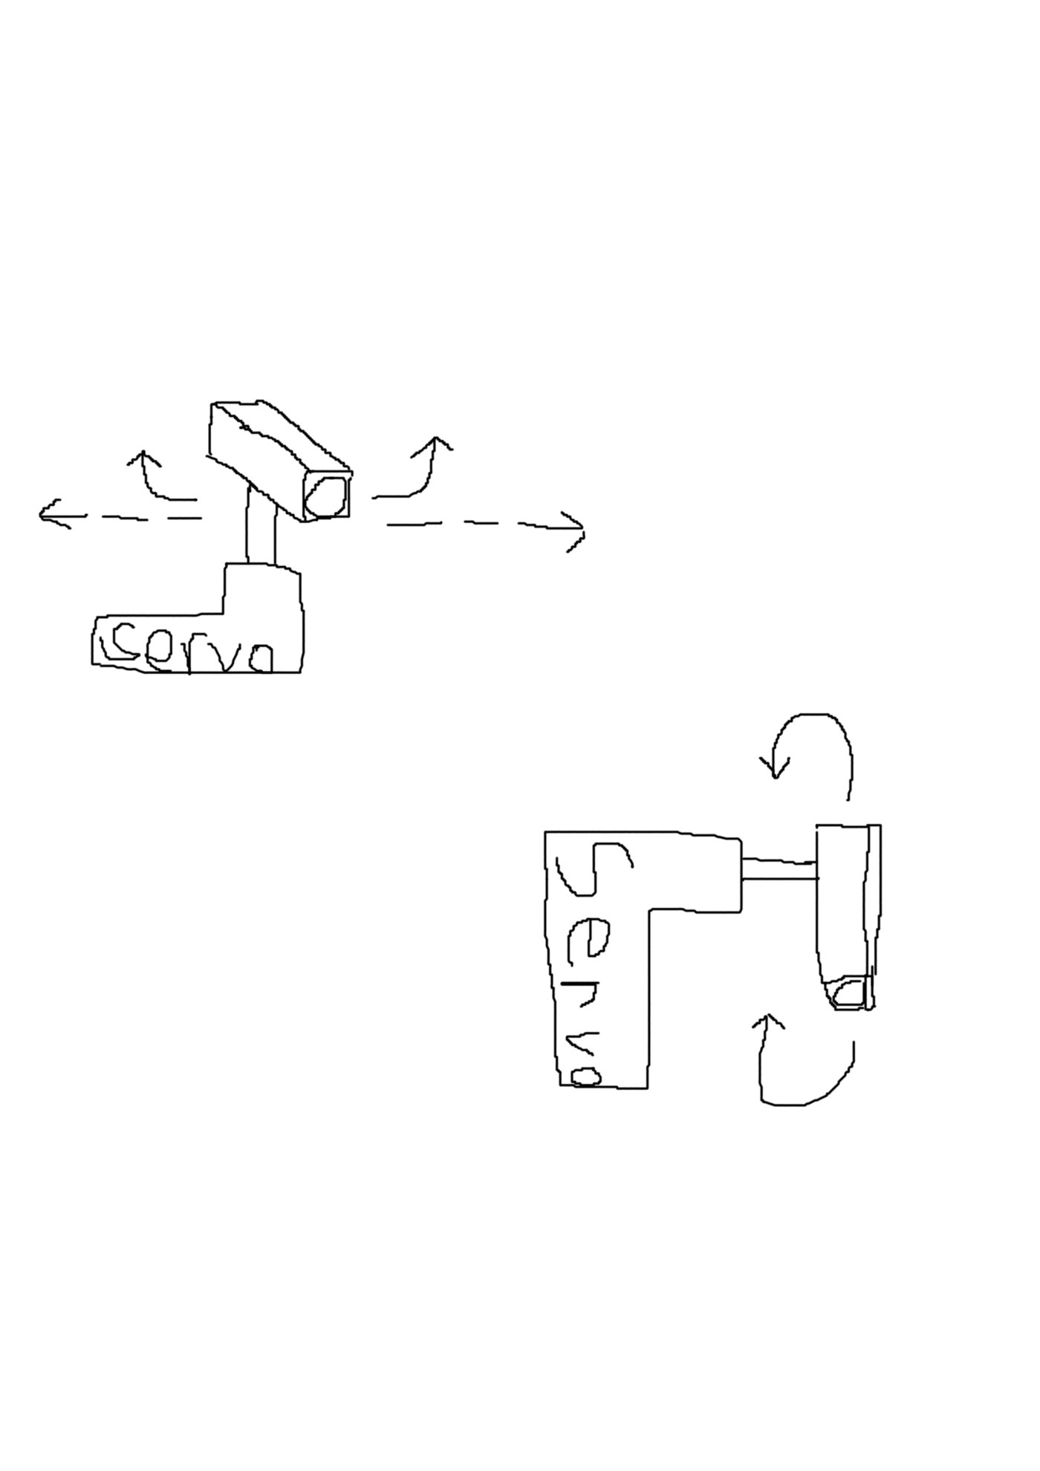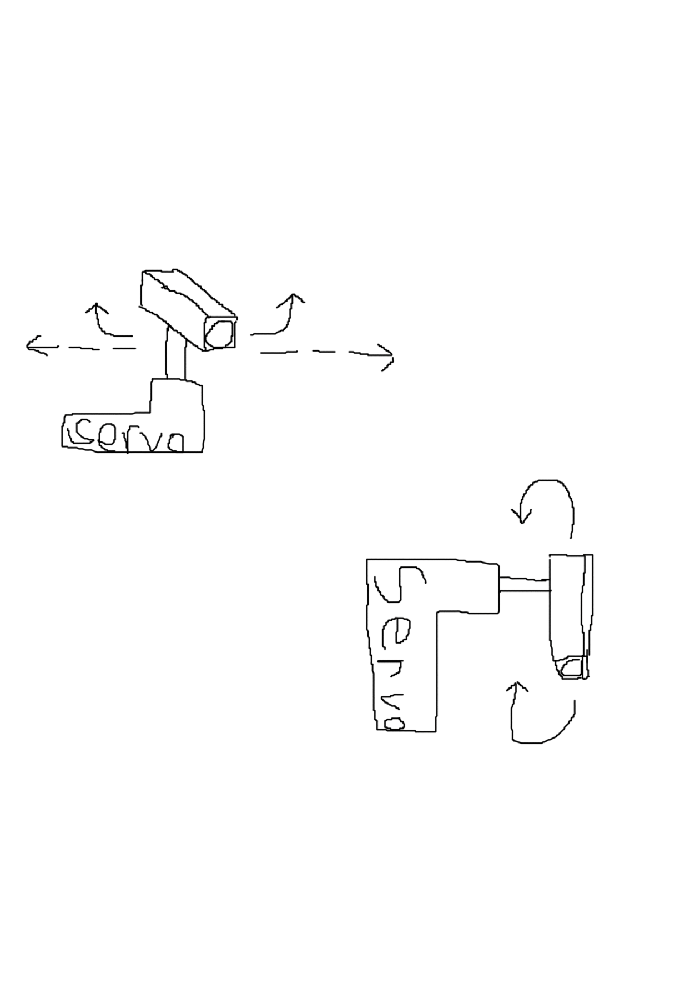Give 10 – 20% leeway.

You want to the camera to have equal sides of the screen on both sides of the detection box and correct when one side decreases.

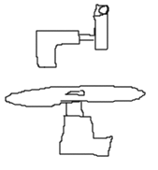

This works by calculating how big of a detection box you have with the object you’re looking for, subtracting that from the total pixel width of the screen (dmax) , then dividing that into two halves, left (dL) and right (dR). If the width of the box isn’t known but the thickness or inner width is do math.

When the object moves from side to side dL or dR will decrease. When that happens the camera needs to rotate to center the object.

The calc is: if dL or dR < arbitrary percentage of screen, move camera